**Module Assessment- 2**

(Java, HTML, CSS, Javascript, Bootstrap, Jenkins, Docker, NodeJS)

**Project Design**

**Problem Statement -1 (Java):**

* Create a shopping Bill program in Java. For generating the shopping bill, we require the product ID, name, quantity, price per item, and total price of the product, and grand total. Besides the product details, we can also add some other details

***Code is attached in the Folder named Shopping_bill.java***

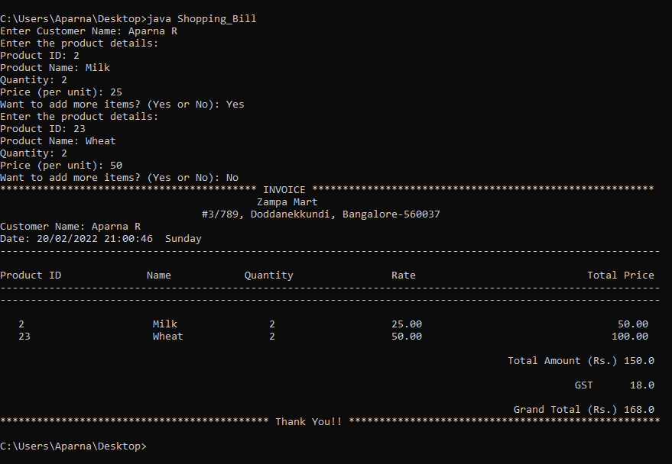

**Problem Statement -2 (HTML, CSS, Bootstrap):**

* Create Training institute static website and add designs using HTML, CSS and Bootstrap. Add pages like Home, About, services (with drop down) and contact us page.

***Code is attached in the Folder named Training-Institute***

**Problem Statement -3 (Javascript):**

* Use JavaScript for add on features to fill the form and submit the form for new admission in above created Training Institute site.

***Code is attached in the Folder named Training-Institute***

**Problem Statement -4 (Docker and Jenkins):**

* Create a pipeline to create the image using docker and spin up the docker container.

***Code is attached in Folder named Question-4***

**Problem Statement -5 (NodeJS and Express):**

Create Restapi with CRUD operations on users enrolled for Trainings.

***Code is attached in Folder named Question-5***

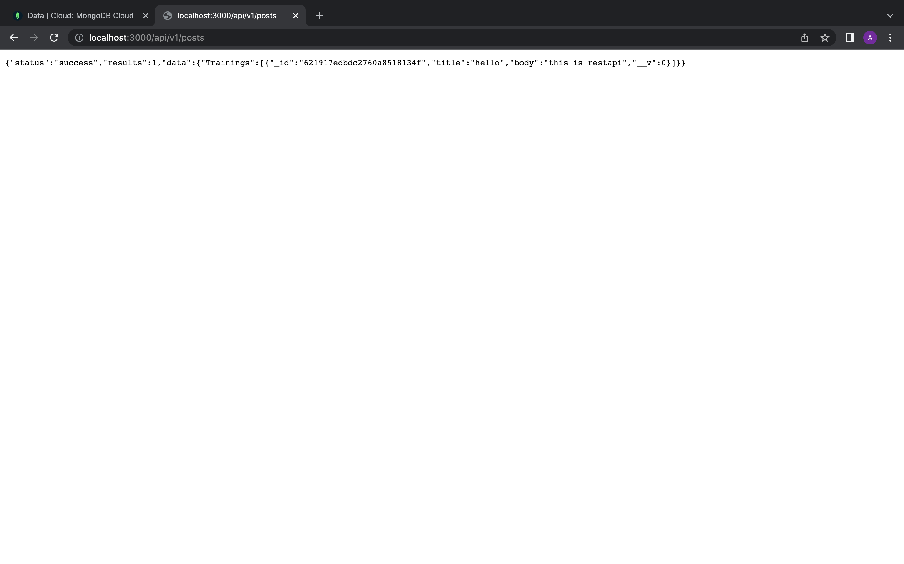

************************************ THE END **************************************